FireCast-AI: Wildfire Risk Classification Using NASA FIRMS Satellite Detections and Open-Meteo Weather Data
A Mini Project Report submitted in partial fulfillment of the requirements for the award of the degree of
BACHELOR OF TECHNOLOGY
in
DEPARTMENT OF [COMPUTER SCIENCE AND ENGINEERING / COMPUTER SCIENCE AND INFORMATION TECHNOLOGY / ARTIFICIAL INTELLIGENCE AND DATA SCIENCE – keep one]
By
CH Adity-2420030669
K Gokul-2420030716
A Aaryan-2420090098
M Satwik-2420090078
Y Gokul-2420090027
Under the Esteemed Guidance of
[Name of the Applied Machine Learning for Text Analytics Faculty]
K L (Deemed to be) University, Koneru Lakshmaiah Education Foundation (Deemed to be University estd. u/s. 3 of the UGC Act, 1956), Off-Campus: Bachupally-Gandimaisamma Road, Bowrampet, Hyderabad, Telangana – 500 043.

DECLARATION
The mini-project report entitled FireCast-AI: Wildfire Risk Classification Using NASA FIRMS Satellite Detections and Open-Meteo Weather Data is a record of bona fide work carried out by [Names and Roll Numbers] in partial fulfillment of the requirements for the award of the B.Tech degree at K L (Deemed to be) University. The work presented in this report is original to the best of our knowledge, and all datasets, tools, code, and external sources used have been appropriately acknowledged.
CH Adity-2420030669
K Gokul-2420030716
A Aaryan-2420090098
M Satwik-2420090078
Y Gokul-2420090027

CERTIFICATE
This is to certify that the mini-project report entitled FireCast-AI: Wildfire Risk Classification Using NASA FIRMS Satellite Detections and Open-Meteo Weather Data is a bona fide work carried out by [Student Names and Roll Numbers] under the supervision of [Faculty Guide] during the academic year [20__–20__], in partial fulfillment of the requirements for the award of the Bachelor of Technology degree at K L (Deemed to be) University.
Signature of the Project Supervisor: ____________________
Signature of the HOD: ____________________
Signature of the External Examiner: ____________________

ACKNOWLEDGEMENT
The success of this project would not have been possible without the timely help and guidance of many people. We express our sincere thanks to everyone who assisted us in one way or another in completing this project.
Our greatest appreciation goes to our guide, [Name of the ALT faculty of the respective section], Department of Computer Science, for tremendous support, encouragement and guidance throughout this project.
We express our gratitude to [HOD name – Dr. P. Venkateshwar (CSE) / Dr. Kaja Shareef (CSIT) / Dr. Sreenath (AI&DS)], Head of the Department, for providing adequate facilities, ways and means by which we were able to complete this project-based lab.
We thank all the teaching and non-teaching staff members who assisted us directly or indirectly. Finally, we sincerely thank our parents, friends and classmates for their kind help and cooperation during our work.
[Name] – [Roll No.]; [Name] – [Roll No.]; [Name] – [Roll No.]

TABLE OF CONTENTS
- Abstract
- Introduction
- Literature Survey
- Problem Statement and Objectives
- Hardware and Software Requirements
- Implementation
- Results and Discussion
- Conclusion and Future Scope
- References

1. ABSTRACT
Wildfire risk is normally judged by manually combining satellite fire reports with weather conditions, which is slow and hard to scale across regions. FireCast-AI is a machine-learning prototype that classifies a location as Low, Medium or High wildfire risk and presents the result in a Streamlit dashboard. Note that this project analyses structured numerical data (satellite detections and weather variables), not free text, so NLP steps such as tokenization and TF-IDF do not apply; the equivalent preprocessing and feature steps are documented instead. The dataset of 8,390 records was built from NASA FIRMS VIIRS SNPP near-real-time fire detections (3,390 fire records) and Open-Meteo weather data, plus 5,000 non-fire locations from low-fire-risk regions. Preprocessing included range filtering, median imputation, five engineered weather features, SMOTE class balancing on training data, standard scaling and SelectKBest feature selection (10 features). XGBoost and Random Forest were tuned with randomized five-fold cross-validation (macro F1), and XGBoost was selected. On a stratified 20% test set (1,678 records) it achieved 89.15% accuracy and 0.764 macro F1, with perfect Low-risk results, F1 of 0.820 for Medium and only 0.471 for High risk. SHAP analysis ranked temperature range and humidity range as the most influential features. These results come from a random split of a single-day dataset and are likely optimistic; they are not evidence of operational accuracy.
Dataset/source and project repository: NASA FIRMS (https://firms.modaps.eosdis.nasa.gov), Open-Meteo (https://open-meteo.com); project repository: [repository URL]

2. INTRODUCTION
Wildfires cause loss of life, damage to ecosystems and property, and large carbon emissions. Authorities need early, region-wide indications of where conditions favour dangerous fires. Satellites such as VIIRS report thousands of active-fire detections every day and weather services publish gridded forecasts, but reading these streams manually and relating them to each other does not scale. Machine learning can learn the relationships between weather, terrain and observed fire intensity and turn them into a simple, consistent risk level.
The application area of this project is wildfire risk classification. Unlike sentiment or spam detection, the input is not text: each input is a numerical record for one location (latitude, daily temperature, humidity, wind, precipitation, evapotranspiration, elevation and derived indices), and the output is one of three classes: Low (0), Medium (1) or High (2) risk. The target users are fire-management analysts, researchers and students who need a quick, explainable risk overview for a chosen area.
The proposed pipeline is: (1) data collection from NASA FIRMS and Open-Meteo, (2) cleaning and labelling, (3) feature engineering and selection, (4) model training and tuning, (5) evaluation with accuracy, precision, recall, F1 and a confusion matrix, (6) SHAP explainability, and (7) a Streamlit dashboard that fetches live data and shows a risk map. The remaining chapters cover the literature survey, problem statement, requirements, implementation, results, conclusion and references.

3. LITERATURE SURVEY
The following studies were reviewed in the project's literature matrix (24 papers in total); six are summarised here.
[1] Exploration of geo-spatial data and ML for wildfire occurrence prediction (2025). The authors predict wildfire occurrence in Central Russia using more than 17,000 verified events over ten years, with weather, terrain and human-activity variables. Random Forest, XGBoost, an autoencoder, ConvLSTM, an attention MLP and RegNetX were compared using accuracy, F1 and AUC. The main finding is that region-specific models are needed because no unified model performed well everywhere. Limitations: a single country, no uncertainty estimation and no model fusion.
[2] Deep learning for wildfire risk prediction: integrating remote sensing and environmental data (2025). This study reviews CNN, LSTM and Transformer models that combine Sentinel-2, MODIS and VIIRS imagery with weather and terrain data. Evaluation is by AUC, accuracy and F1, with Grad-CAM and SHAP for explanation. It finds that integrating remote sensing with environmental variables improves risk prediction. Its limitation is that findings are dataset-specific and largely come from a review.
[3] AutoML-Fire: automated machine learning for forest fires (2025). The work models wildfire occurrence across India using meteorological, topographic and socio-economic data and MODIS fire products. Bayesian-optimised AutoML selects the model, SMOGN handles imbalance and SHAP explains the results (R-squared and RMSE are reported). Bayesian optimisation outperformed manual tuning. It is a regression formulation and uses MATLAB, which limits direct comparison with classification work.
[4] Environmental drivers and spatial prediction of forest fires in the Western Ghats, India (2023). Using Landsat and MODIS vegetation and temperature data with weather, terrain and distance-to-road variables, the authors compare Random Forest, XGBoost and ensembles for fire susceptibility. Performance is reported with AUC, accuracy and Kappa. Ensemble tree models worked well for the region. The task is binary susceptibility with no temporal modelling.
[5] Forest fire susceptibility: sensitivity and uncertainty analysis (2023). This paper applies deep neural networks and ensemble models with Monte Carlo uncertainty quantification. It identifies evapotranspiration and rainfall as key ignition factors and shows that uncertainty should be reported alongside predictions. It is limited to binary susceptibility rather than multi-class risk levels.
[6] Wildfire risk prediction: a review (arXiv 2405.01607, 2024). The review organises the field into traditional, machine-learning and deep-learning generations and covers time-series, image and spatio-temporal models. It highlights multimodal models and feature collinearity as important themes. As a review it contains no new experiments.
Comparison and gap. The surveyed work mostly treats fire as a binary (fire / no fire) or susceptibility problem, relies on tree ensembles such as Random Forest and XGBoost, and increasingly uses SHAP for explanation. Few studies address three-level risk classes, and spatially independent validation is rare. This mini-project implements a three-class risk classifier with XGBoost, SHAP explanations and a live dashboard, and it documents its own validation weaknesses openly (Section 7).

4. PROBLEM STATEMENT AND OBJECTIVES
Problem Statement: To classify the wildfire risk level (Low, Medium or High) of a geographic location from satellite fire-detection data and weather variables using machine learning, and to present the prediction with explanations in an interactive dashboard.
Problem Description: Wildfire monitoring requires combining fast-changing satellite detections with weather and terrain information. Manual assessment is slow, subjective and difficult to repeat over large areas. Intended users are analysts and researchers who need a quick, explainable risk map. Existing manual approaches do not scale, and many automated studies give only a binary fire/no-fire answer.
Objectives and status:
Objective | Status
Obtain and inspect a labelled dataset; document source, size, fields and class distribution | Achieved: 8,390 records, 14 raw columns, three classes
Clean and preprocess the data | Achieved: range filtering, median imputation, outlier removal
Convert raw inputs into numerical features | Achieved: 16 candidate features, 10 selected (no text vectorisation applies)
Train and compare machine-learning models | Achieved: XGBoost vs Random Forest, tuned with randomized search
Evaluate with accuracy, precision, recall, F1 and confusion matrix | Achieved on a random 20% hold-out set
Interpret errors and discuss bias, limitations and improvements | Achieved: SHAP plus documented leakage and confounding risks
Build a demonstration interface | Achieved: Streamlit dashboard (app.py)

5. HARDWARE AND SOFTWARE REQUIREMENTS
Hardware Requirements:
- Computer or laptop with a modern multi-core CPU; 8 GB RAM or more recommended.
- Internet access for FIRMS and Open-Meteo API calls and for installing packages; a GPU is not required.
- Sufficient disk space: the project folder with saved models, Parquet datasets and caches is roughly 170 MB compressed.
Software Requirements:
- Python 3.x (versions in requirements.txt are not pinned).
- Libraries: streamlit, pandas, numpy, geopandas, scikit-learn, xgboost, shap, folium, streamlit-folium, requests, python-dotenv, joblib, imbalanced-learn, matplotlib, seaborn.
- Data: NASA FIRMS CSV/API data and Open-Meteo JSON API responses, stored as CSV and Parquet.
- A NASA FIRMS API key supplied through the FIRMS_API_KEY environment variable or a .env file (never commit the key).
- Optional: Git for version control. Open-Meteo's free tier needs no key.

6. IMPLEMENTATION

6.1 Data and task
The task is three-class classification of wildfire risk: 0 = Low, 1 = Medium, 2 = High. Fire records come from the NASA FIRMS VIIRS SNPP near-real-time product for nine fire-prone regions (USA, South America, Southern Europe, Central Africa, Southeast Asia, Australia, Russia/Siberia, India and Southern Africa) over the most recent two days. Weather and elevation for each location come from the Open-Meteo forecast API (daily maximum/minimum temperature, maximum/minimum relative humidity, maximum wind speed, precipitation, ET0 evapotranspiration). Both sources are openly accessible; each provider's terms of use apply (Open-Meteo's free tier is intended for non-commercial use).
Labels are assigned as follows: a fire detection with FRP >= 10 MW and brightness (bright_ti4) >= 320 K is High risk (2); any other fire detection is Medium risk (1); and non-fire locations, sampled uniformly (seed 42) from eight historically low-fire-risk regions such as Northern Europe, Japan/Korea, New Zealand and the UK, are Low risk (0).
The final dataset (data/wildfire_dataset.csv) has 8,390 rows. It was split 80/20 with stratification (random_state = 42) into 6,712 training and 1,678 test records. No separate validation set was held out; model selection used five-fold cross-validation inside the training data.

6.2 Preprocessing and features (replacing NLP preprocessing)
Because the inputs are numeric, tokenization, stop-word removal, stemming and TF-IDF were not used. The equivalent steps were:
- Cleaning: removed detections with missing or out-of-range coordinates, kept brightness within 250–500 K and FRP >= 0; dropped rows missing temperature, humidity or wind; filled remaining missing numbers with column medians; replaced infinite values.
- Sampling: fire records were stratified-sampled if above a 5,000 cap to keep API calls manageable; non-fire rows without weather data used a latitude-band climatological fallback.
- Engineered features: Drying_Power_Index = Temperature_max x WindSpeed_max; Fuel_Combustibility = ET0 / (Precipitation + 0.1); Humidity_Range = Humidity_max - Humidity_min; Temperature_Range = Temperature_max - Temperature_min; Abs_Latitude = |Latitude|.
- Candidate feature set (16): Latitude, Longitude, Temperature_max/min, Humidity_max/min, WindSpeed_max, Precipitation_mm, ET0_mm, Elevation_m, Day_of_Year and the five engineered features. FRP and brightness are used to create the label and are not model inputs.
- Class balancing: SMOTE applied to the training set only, giving 4,000 samples per class (12,000 in total).
- Scaling and selection: StandardScaler fitted on the SMOTE-balanced training data, then SelectKBest (ANOVA F-test, k = 10). Selected features: Temperature_max, Temperature_min, Humidity_min, ET0_mm, Elevation_m, Drying_Power_Index, Fuel_Combustibility, Humidity_Range, Temperature_Range and Abs_Latitude. The test set was only transformed, never used for fitting.

6.3 Model training and evaluation
Two models were tuned with RandomizedSearchCV using stratified five-fold cross-validation and macro F1 as the score (random seed 42): XGBoost (50 iterations over max_depth, learning_rate, n_estimators, subsample, colsample_bytree and min_child_weight) and Random Forest (30 iterations over n_estimators, max_depth, min_samples_split and min_samples_leaf). The model with the higher cross-validated macro F1 is evaluated on the test set. The saved model is an XGBClassifier (objective multi:softprob) with n_estimators = 300, max_depth = 8, learning_rate = 0.2, subsample = 0.7, colsample_bytree = 0.7 and min_child_weight = 1. A SHAP TreeExplainer was fitted for explanations.

A. Project workflow and modules
Stage | File
Data acquisition, labelling, and dataset export | src/train_model.py (build_dataset), data/wildfire_dataset.csv
Live data calls (weather, FIRMS) used by the dashboard | src/data_processing.py
Feature engineering, training, tuning, evaluation, SHAP and artifact export | src/train_model.py
Plots and saved artifacts | models/confusion_matrix.png, models/shap_summary.png, xgb_wildfire_model.pkl, scaler.pkl, feature_selector.pkl, selected_features.pkl, shap_explainer.pkl
Next-generation leakage-controlled dataset builder (not yet used for modelling) | src/data/ (event_clustering, negative_sampling, label_generation, build_firecast_dataset), scripts/validate_dataset_v2.py
Tests | tests/ (live monitoring and dataset validation tests)

B. Machine-learning implementation
The comparison models are XGBoost (gradient-boosted trees, chosen for strong performance on tabular data and consistency with the surveyed literature) and Random Forest (bagged trees, a robust baseline). Both were trained on the same scaled, selected features. Key parameters are listed in Section 6.3; full code is in src/train_model.py. Because the pipeline uses SMOTE, scaling and selection, all three were fitted on training data only.

C. Demonstration / dashboard
The Streamlit application (app.py) lets the user choose a preset or custom latitude/longitude, fetches current weather from Open-Meteo for a configurable grid, queries recent VIIRS detections from NASA FIRMS, builds the same engineered features, loads the saved model, scaler, selector and SHAP explainer, and displays risk zones on a Folium map with class probabilities, model metrics and SHAP explanations. It also classifies live FIRMS detections into alert levels using FRP and brightness rules. Run it with: pip install -r requirements.txt, then streamlit run app.py. The five artifact files must be present in models/. Retraining is run with python src/train_model.py.

7. RESULTS AND DISCUSSION

7.1 Dataset summary and class distribution
Class | Records | Share | Source
Low risk (0) | 5,000 | 59.6% | Sampled non-fire locations
Medium risk (1) | 2,533 | 30.2% | FIRMS detections below the High threshold
High risk (2) | 857 | 10.2% | FIRMS detections with FRP >= 10 MW and brightness >= 320 K
Total | 8,390 | 100% | 14 raw columns before feature engineering
The data is imbalanced, with High risk the smallest class, which is why SMOTE was applied to the training data. The file contains 5 exact duplicate rows and no missing values after cleaning. Every record has the same Day_of_Year value (301), so the dataset is a single-day snapshot and carries no seasonal information; Day_of_Year was not selected as a feature.

7.2 Model evaluation on the held-out test set (1,678 records)
Metric | Value
Accuracy | 89.15% (1,496 of 1,678 correct)
Macro precision | 0.763
Macro recall | 0.764
Macro F1 | 0.764

Class | Precision | Recall | F1 | Support
Low | 1.000 | 1.000 | 1.000 | 1,000
Medium | 0.822 | 0.819 | 0.820 | 507
High | 0.468 | 0.474 | 0.471 | 171
Per-class values were computed from the saved confusion matrix. The cross-validated macro-F1 scores of XGBoost and Random Forest were printed during training but are not stored in the supplied files, so a numerical model-comparison table cannot be given; XGBoost was the winner of that comparison.

7.3 Confusion matrix
Figure 1 – Confusion matrix (models/confusion_matrix.png)
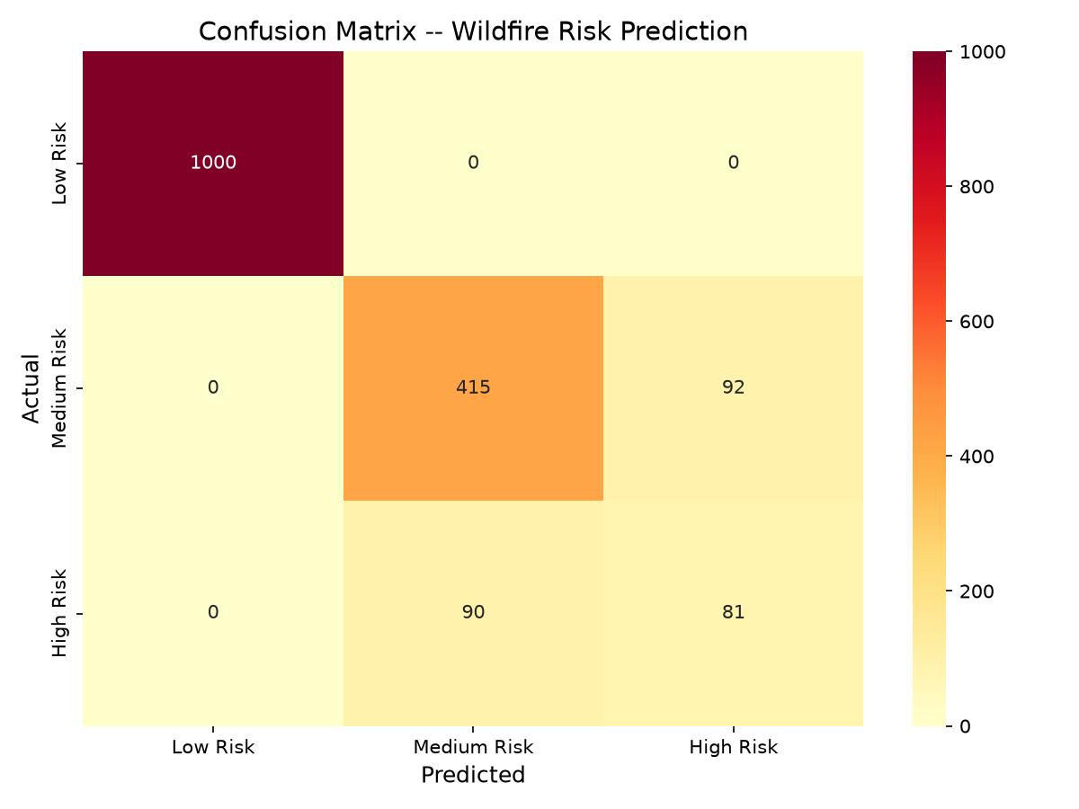
Actual \ Predicted | Low | Medium | High
Low | 1000 | 0 | 0
Medium | 0 | 415 | 92
High | 0 | 90 | 81
All 1,000 Low-risk records are classified correctly and no fire location is ever predicted as Low. All errors occur between Medium and High: 92 Medium records were predicted High and 90 High records were predicted Medium. Fewer than half of the High-risk records (81 of 171) were found, so High-risk detection is the weakest part of the model.

7.4 Feature importance (SHAP)
Figure 2 – Global SHAP feature importance (models/shap_summary.png)
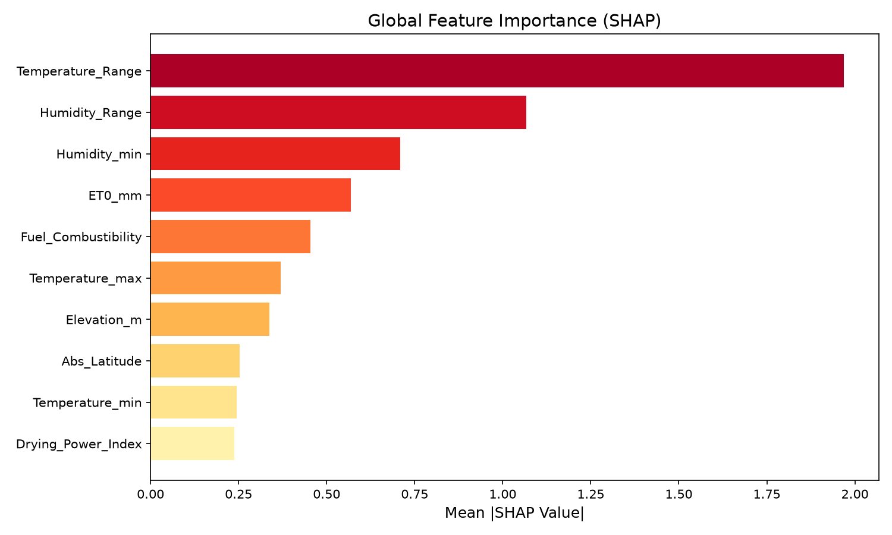
Approximate mean absolute SHAP values read from the plot: Temperature_Range about 1.97, Humidity_Range about 1.07, Humidity_min about 0.71, ET0_mm about 0.57, Fuel_Combustibility about 0.45, Temperature_max about 0.37, Elevation_m about 0.34, Abs_Latitude about 0.25, Temperature_min about 0.24 and Drying_Power_Index about 0.24. The diurnal temperature and humidity swings and the dryness indicators dominate, which agrees with the surveyed literature identifying evapotranspiration and humidity as ignition drivers. Large importance of Temperature_Range, however, may partly reflect regional climate differences rather than fire behaviour (see below).

7.5 Errors, bias and limitations
- Perfect Low-risk score is suspicious. Low-risk rows come from eight fixed, low-fire regions while fire rows come from nine other regions, so the model can partly learn location and climate rather than fire danger. Non-fire rows without weather data also received climatological default values. This confounding likely inflates accuracy.
- Label construction. Medium and High are defined by satellite FRP and brightness thresholds, which describe an already burning fire rather than future risk. The model therefore learns to predict a fire's observed intensity class from weather, not forecast risk.
- Random split. Nearby detections from the same fire can fall in both training and test sets, so the test score is not spatially or temporally independent. Results are optimistic.
- Single-day data. All records share one day-of-year, so the model cannot be said to generalise across seasons.
- Class imbalance. High risk is only 10.2% of the data and has F1 of 0.471; SMOTE interpolation does not add new real examples.
- Uncalibrated probabilities and no operational validation. Probability calibration (ECE, Brier score) was not measured, and the dashboard also depends on live API availability. There are no pinned dependencies or deployment configuration.
- Privacy. The data consists of environmental measurements and contains no personal data. API keys must be kept out of the repository.
- Planned V2 dataset. A separate leakage-controlled dataset builder was developed (3,167,202 candidate samples: 2,235,124 train, 405,532 calibration and 526,546 test, split by non-overlapping 5-degree spatial blocks, with historical weather features and a 24-hour prediction horizon). No model has yet been trained or evaluated on it, so it is reported only as a dataset-generation result.

8. CONCLUSION AND FUTURE SCOPE
Conclusion. This project built FireCast-AI, a three-class wildfire risk classifier using NASA FIRMS detections and Open-Meteo weather data. After cleaning, five engineered features, SMOTE, scaling and selection of ten features, a tuned XGBoost model achieved 89.15% accuracy and 0.764 macro F1 on a random 20% test set, with perfect Low-risk results, F1 of 0.820 for Medium and 0.471 for High. SHAP showed that temperature range and humidity measures drive predictions, and a Streamlit dashboard demonstrates live predictions. All stated objectives were implemented. The most important limitation is that the evaluation uses a random split on a single-day, geographically confounded dataset, so the scores should not be read as operational accuracy and High-risk detection remains weak.
Future scope.
- Train and evaluate models on the leakage-controlled V2 dataset using spatial-block and temporal validation.
- Replace the fixed non-fire regions with matched negatives from the same regions and seasons to remove geographic confounding.
- Improve High-risk recall with class weighting, threshold tuning and ordinal-aware loss, since mistaking High for Low is more costly than mistaking High for Medium.
- Calibrate probabilities (for example temperature scaling) and add uncertainty measures such as conformal prediction.
- Add real vegetation or satellite imagery features; the current NDVI value in the dashboard is only a proxy.
- Collect multi-season data, pin dependencies, add automated tests, and test deployment latency.

9. REFERENCES
- NASA FIRMS – Fire Information for Resource Management System, VIIRS S-NPP Near Real-Time active fire data. NASA. https://firms.modaps.eosdis.nasa.gov (accessed October 2026).
- Open-Meteo – Free Weather API (forecast and archive). https://open-meteo.com (accessed October 2026).
- Exploration of geo-spatial data and machine learning for wildfire occurrence prediction. Scientific Reports, 2025. https://doi.org/10.1038/s41598-025-94002-4
- Deep learning for wildfire risk prediction: integrating remote sensing and environmental data. ISPRS Journal of Photogrammetry and Remote Sensing, 2025. https://doi.org/10.1016/j.isprsjprs.2025.06.002
- AutoML-Fire: automated machine learning for forest fires. Environmental Modelling & Software, 2025. https://doi.org/10.1016/j.envsoft.2025.106578
- Environmental drivers and spatial prediction of forest fires in the Western Ghats, India. Forest Ecology and Management, 2023. https://doi.org/10.1016/j.foreco.2023.121057
- Forest fire susceptibility: sensitivity and uncertainty analysis. Advances in Space Research, 2023. https://doi.org/10.1016/j.asr.2023.03.026
- Wildfire risk prediction: a review. arXiv:2405.01607, 2024. https://arxiv.org/abs/2405.01607
- Scikit-learn documentation. https://scikit-learn.org/stable/
- XGBoost documentation. https://xgboost.readthedocs.io
- SHAP documentation. https://shap.readthedocs.io
- imbalanced-learn documentation (SMOTE). https://imbalanced-learn.org
- Streamlit documentation. https://docs.streamlit.io

